**BASIC STRUCTURE OF C LANGUAGE:**

The program written in C language follows this basic structure. The sequence of sections should be as they are in the basic structure. A C program should have one or more sections but the sequence of sections is to be followed.

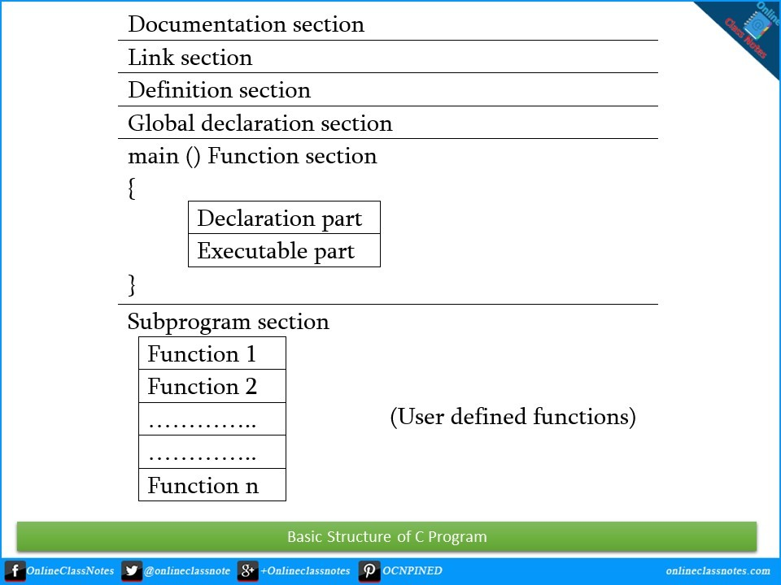

**1. DOCUMENTATION SECTION :** comes first and is used to document the use of logic or reasons in your program. It can be used to write the program's objective, developer and logic details. The documentation is done in C language with /* and */ . Whatever is written between these two are called comments.

**Example:**

/*

Name of the program,date..etc

*/

**2. LINKING SECTION or Pre-Processor section** : This section tells the compiler to link the certain occurrences of keywords or functions in your program to the header files specified in this section.

**e.g.** #include <stdio.h>

3. **DEFINITION SECTION :** It is used to declare some constants and assign them some value.

e.g. #define MAX 25

Here #define is a compiler directive which tells the compiler wherever MAX is found in the program replace it with 25.

**4. GLOBAL DECLARATION SECTION :** Here the variables which are used through out the program (including main and other functions) are declared so as to make them global(i.e accessible to all parts of program)

**e.g.** int i; (before main())

5. **MAIN FUNCTION SECTION** : It tells the compiler where to start the execution from

main()

{

point from execution starts

}

**main function has two sections**

1. **declaration section** : In this the variables and their data types are declared.

Local declarations

The variable that is declared inside a given function or block refers to as local declarations.

void main()

{

int i = 2;

i++;

}

**2. Executable section** : This has the part of program which actually performs the task we need.

**6. SUB PROGRAM OR FUNCTION SECTION** : The subprogram section contains all the user defined functions that are used to perform a specific task. These user defined functions are called in the main() function.program needs.

SIMPLE ‘C’ PROGRAM:

/* simple program in c */

#include<stdio.h>

void main()

{

printf(“welcome to c programming”);

} /* End of main */